Operating Mode

Set up for CW Mode

Operate with a hand key, paddles or an external keyer / controller device.

Insert the key plug (three-wire) stereo plug into the KEY interface; see Wiring
Press the MODE button to switch the mode to CW (or CWR);

Press the KEY button function to scroll through Speed, M/L/R for manual or Left or Right Dah preference for paddle, Iambic A or B, QSK [ OFF will allow radio to operate as a code practice oscillator], QSK Time (delay between End of Key Press and RX on), Ratio for dit/dah spacing (3 is standard).
2nd Menu (Press Function Key - lamp is ON):

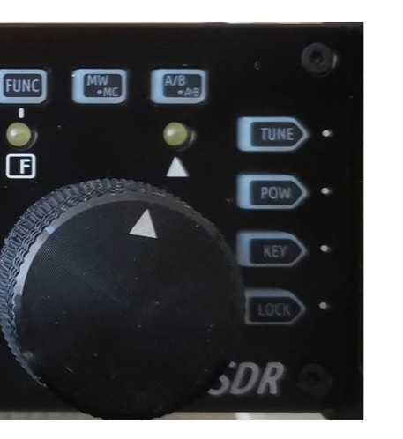
CW Volume and CW Tone - side tone on successive press VFO Knob selects value
Press Function to exit 2nd Menu Press Key to exit Keyer Menu
Long Press of CW enables CW decode.

See Adjusting CW Filter in Adjustments

You can use the G90 as a CW code trainer:
The operation method is as follows: In the [KEY] button function, the QSK function can be turned off. In this state, when the keyer is pressed, the transceiver has a CW side tone, but Does Not emit RF.

27

If you find your unit is not Transmitting, CHECK the QSK
Setting. QSK must be ON to transmit

Set CW or CW-R mode with Mode buttons Set CW send speed using Key button press Set Straight key (M) or Left or Right Dah Set Iambic A or B
Set QSK delay – 0 is no delay, RX between sent elements In 2nd Menu set CW Volume
In 2nd Menu set CW Side Tone

Adjust Bandwidth
The B (Bandwidth) value is the difference between the Low and High filter settings. The Bandwidth display does not show correctly in USB mode but works the same.
We want the Low Filter setting lower than the CW side tone setting. So if you set 700 Hz in the side tone and you want a Bandwidth of 500hz, set the Low Filter to 450 Hz. Set the High Filter to 950 Hz. The displayed bandwidth will be 500 Hz centered on 700 Hz. When receiving signals in CW, the CW indicator will light between 450 Hz and 950 Hz. In addition CW will be decoded when Decode is on and the signal is within the bandwidth. Delta lamp lights when within the CW bandwidth.

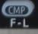
To adjust the Lower bandwidth value, Press Function button and ensure Function lamp is on. Now Press the Fil – L

The Filter display will show L = and a value, this is the Low filter setting. Change it using the Main Knob. Press the Function button to exit.

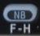
Next Press Function and where the Filter display now shows H= and a value. Adjust this value using the Main Knob. Press Function button to exit.
With a narrow CW filter remember to tune in 100 Hz steps to avoid over stepping stations.

Operating SSB Communication

Set LSB or USB for the Band using Mode buttons Plug the Microphone into the Microphone jack.
Use only the provided Xiegu microphone to prevent damage to you rig.

Set the Receiver bandwidth
Bandwidth Adjustment
The B (Bandwidth) value is the difference between the Low and High filter settings.
To adjust the Lower bandwidth value, Press Function button and ensure Function lamp is on. Now Press the Fil – L

The Filter display will show L = and a value, this is the Low filter setting. Change it using the Main Knob. Press the Function button to exit.
Next Press Function and where the Filter display now shows H= and a value. Adjust this value using the Main Knob. Press Function button to exit.
SSB bandwidth for voice communications should be > than
2.4 Khz.

29

To Enable VOX
Press the Function button, press the volume button to turn VOX on and off.
It is advisable to Press the LOCK button to lock the functions selected so an inadvertent button press Does Not change the set parameters

  - To Enter and Recall Memory Channels

Enter settings into Channel Memory
    - In VFO mode, adjust to the required frequency, mode, advanced function status and other parameters;
    - Press the [ MW/MC ] button to start the channel storage operation;
    - Rotate the main knob to select the channel number to be stored, and short press the MW button to complete the channel storage;
    - If the current channel has stored information, using this channel number for storage again will clear the previous channel information and save the current channel information.
Bring up the storage channel:

1、 If you press the [VM] button on the panel in VFO mode, you will enter channel mode;
2、 Rotate the main knob to switch the current channel.
Clearing channel storage:

- In the channel mode, operate the second function of the [MW/MC] button to start the channel clear function;

- At this point, the channel number starts to flash. Rotate the main knob to the corresponding channel number and press the main knob to complete the channel clear.

To Write stored Channel info to VFO
- Press VM and use the VFO knob to choose the desire ChannelMemory
- Write the Channel information to VFO A, Press Function button
- Next Press A/B button
- Press Function button – off, then Press VM to exit Channel mode.

  - Using Secondary (System) Menu

Available parameters are:

Mic - define buttons: up/dn, F1 button, F2 button. LCD brightness level set - BL%
Aux in Vol. For I & Q volume from computer Aux out Vol. For I &Q output volume to computer Version (Display only)

Long press the FUNC button to enter 2nd System Menu

Short press VM button for next menu item or short Press PRE button to go to previous function.
Turn Main Knob to set function parameter or mic button function. Short press CMP button to save and exit.
Short press AGC button to exit without saving.

31

  - Operating Digital Modes

The G-90 is designed to provide I / Q output, via Line In and Line Out on the ACC port. To ensure correct communication with the computer attached, the signals must be of significant strength.
The I & Q on the I / Q jack are on a Stereo Jack and you must plug a stereo connector into this and into the computer's STEREO input jack.
Failing to have a Stereo input on the computer means No I/Q input should be attempted, damage will occur to the G-90. A USB dongle with Stereo input should be used instead on the computer.
There must be Proper shielding on the cable this limits the noise passed in on the I & Q signals.

Operating method：
    - In the system menu, using ACC port line input, select: AUX LINE IN. Set the appropriate input volume.
    - In the system menu, select: AUX AFOUT VOLUM to set the appropriate output volume.

The G90 transceiver can be connected to a computer to perform various data communication with the corresponding computer software.

Digital connections:
Connect the computer audio output/input to the G90 from the ACC port (MINI-DIN8).
Insert the data cable into the COMM port, connect the G90 to the computer, and ensure that the computer driver of the data cable is installed correctly. The PC software can control the G90 transceiver; Adjust the volume of G90 and the input/output volume of ACC port to the appropriate values. Observe

the software interface to avoid the Audio frequency amplitude being too large and unable to communicate.

Select the corresponding working mode to perform data communication.
In order to prevent interference, the radio and computer must be well grounded. Please install the EMC magnetic ring for the data cable and audio cable, and install it as close as possible to the radio.
The G90 uses the standard CIV instruction set. You can use the standard instructions in this instruction set to remotely control the transceiver. You can also use the CIV instructions oft other software to control the G90.

Check the G-90 forum for current digital setup information and help. https://www.facebook.com/groups/578581345625251/?ref=group_header

